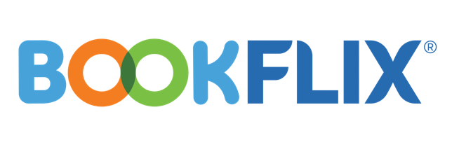

Dear Parent,

Good news! INFOhio (www.infohio.org) provides access to BookFlix at no cost to Ohio families that you and your child can access from home! Scholastic BookFlix is an online literacy resource that pairs classic video storybooks from Weston Woods with related nonfiction eBooks from Scholastic to build a love of reading and learning. This engaging resource for children in grades PreK-3 will help early readers develop and practice essential reading skills and introduces students to a world of knowledge and exploration.

Your children can access Scholastic BookFlix anywhere there is an internet connection. This interactive resource will help them get excited about reading and books and extends learning beyond school hours. BookFlix includes:

- More than 150 classic video storybooks each paired with a related nonfiction eBook.
- Spanish language versions of more than 40 pairs.
- Read-aloud supports so students can hear each book narrated and also hear definitions of key words and directions for each activity.
- Educational games and activities so children can show what they have learned.
- Safe, age-appropriate websites selected by Scholastic’s editors so kids can extend their learning on a topic.
- Meet the author section to learn more about the author of each fiction book.

Scholastic BookFlix is specifically created to support non-, beginning and reluctant readers – it’s the perfect resource for independent reading practice at school and at home!

To get started with BookFlix, go to www.infohio.org. Click Grades K-5 and choose BookFlix. Use the username and password to log in, if needed.
INFOhio username/password

Happy reading!

Sincerely,

