ISearch for Librarians Checklist and Guided Notes

Use this Guide for the following lessons in the ISearch for Librarians Training Class:
- Getting to Know ISearch
- Finding ISearch on the INFOhio Website
- Search Basics
- Getting the Results You Want
- Saving Items
- Getting to Know ISearch Mobile
- Searching in ISearch Mobile
- Accessing My Account from ISearch Mobile
- ISearch Customizations
- Linking to Your ISearch Landing Page
- Embedding the ISearch Widget on a Webpage
- ISearch Use Data

Fill in the blanks in the text below using words from the training site.

Getting to Know ISearch
ISearch is your school library _______________ + INFOhio.

Label the main components of the ISearch landing page:

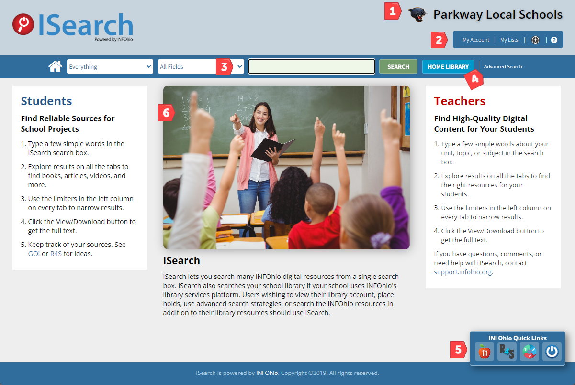

1. ________________________________ 4. ________________________________
2. ________________________________ 5. ________________________________
3. ________________________________ 6. ________________________________

Label the main components of the ISearch My Library tab results screen.

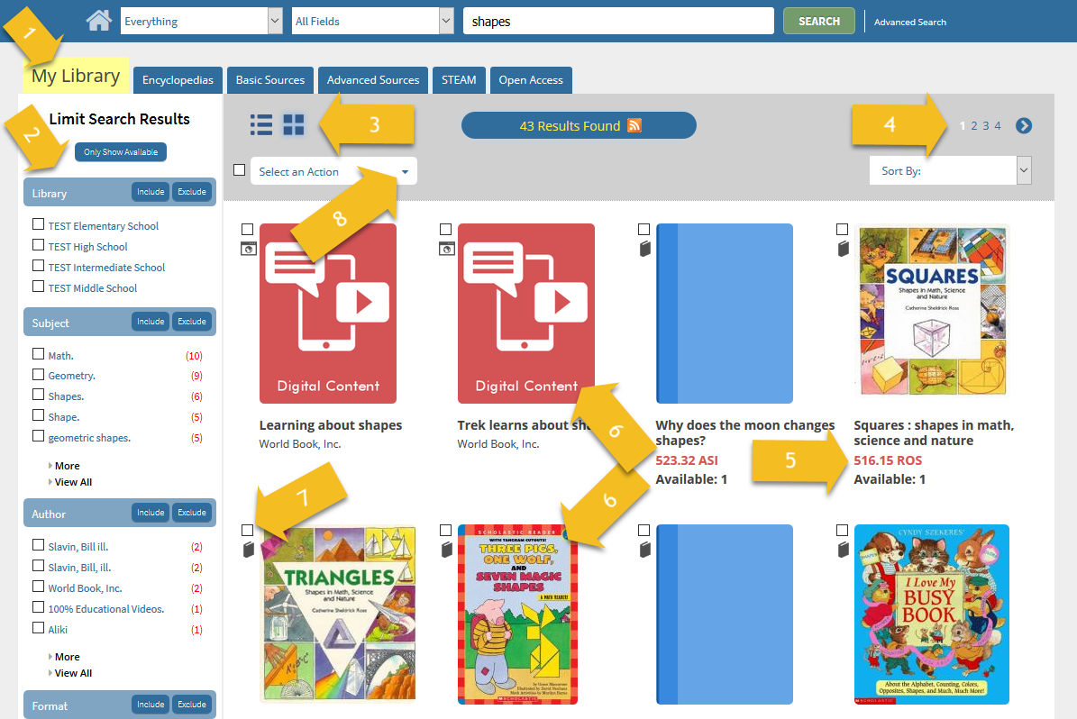
1. ________________________________ 5. ________________________________
2. ________________________________ 6. ________________________________
3. ________________________________ 7. ________________________________
4. ________________________________ 8. ________________________________

Briefly describe the kinds of results you’ll find under each of the tabs in ISearch.

My Library:
Encyclopedias:
Basic Sources:
Advanced Sources:
STEAM:
Open Access:
Finding ISearch on the INFOhio Website
What are three different ways users can access ISearch?
1. ________________________________
2. ________________________________
3. ________________________________

Using the following formula, build your ISearch Welcome Page URL and verify that it works.
https://www.infohio.org/opac/?itc/instance/library

______________________________________________________________________

Search Basics
More than 85% of INFOhio catalog searches are _______________ searches. Most of your users type _______________ or _______________ words in the search box.

ISearch assumes the Boolean operator _______________ so there is no need to type AND in your search.

ISearch _______________ the Boolean operator NOT. However, ISearch honors - (the minus sign) in _______________ of NOT.

ISearch honors _______________ marks.

If you or your users are looking for information on a topic, you will likely need to try _______________ searches.

Getting the Results You Want
On the My Library tab, there are two ways to apply limiters. List those two ways below.
1.____________________________________________________________________________
2.____________________________________________________________________________

The _______________ limiter on the My Library tab is using the Library of Congress subject headings from your catalog records.

The more limiters you apply, the _______________ results you'll get, but your results will be more _______________.

Because the ISearch limiters are using your catalog _______________, it's important that you maintain _______________ records.

In order for you and your patrons to be able to use the Reading Level limiter, you need to have catalog records that include _______________ levels or _______________ levels.

In order for you and your patrons to be able to use the _______________ limiter, you need to have catalog records that include Accelerated Reader or Reading Counts information.

The limiters are _______________ to each tab. In other words, applying a limiter on the My Library tab _______________ apply the same limiter on the Encyclopedias tab. As you visit each new tab, you will be _______________ with the results from your search.

Saving Items
Most users will log in to My Account using their _______________or _______________ as the User ID and their birth month and birthday (MMDD format) as the _______________.

What four tabs will you find once you have logged into My Account?
1. ________________________________ 3. ________________________________
2. ________________________________ 4. ________________________________

To save items to My Lists you need to log in to _______________.

What two types of lists are available when adding items to My Lists?
1. ________________________________ 2. ________________________________

Getting to Know ISearch Mobile
List the three ways to access ISearch Mobile:
1. ____________________________________________________________________
2. ____________________________________________________________________
3. ____________________________________________________________________

To determine your ISearch Mobile link, you will need to locate your school’s unique ISearch URL and add _______________ to the end of the URL.

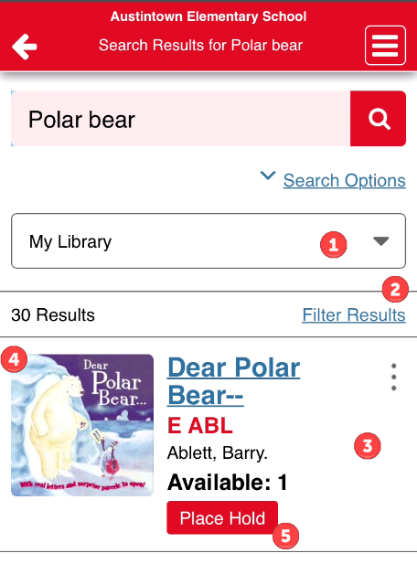
Label the main components of the ISearch Mobile results screen:

1. ________________________________
2. ________________________________
3. ________________________________
4. ________________________________
5. ________________________________

To exit Mobile mode click the ______________ menu, and click
Exit Mobile/Accessible Mode. This will take you back to ISearch.

Searching in ISearch Mobile
ISearch Mobile is designed to _______________ the tabs you would normally see when using ISearch.

This makes for a more _______________ appearance while still maintaining all of the _______________ that make ISearch such a powerful research machine.

When a user performs a search, the results default to the _______________ tab of results.

Results will only come from your _______________ collection unless you use the _______________ to choose from one of the other collections: _______________, Basic Sources, _______________, STEAM, and _______________.

Accessing My Account from ISearch Mobile
To log in to My Account, click the _______________ menu to access the Main Menu.

To access My Lists, click the _______________ menu to access the Main Menu.

List the two types of lists available in My Account.
1. ________________________________
2. ________________________________

ISearch Customizations
List the options for customizing ISearch:

1. ________________________________4. ________________________________
2. ________________________________5. ________________________________
3. ________________________________

A _______________ River lets you showcase materials in your library on your ISearch landing page. A Book River requires that library staff run a _______________ to periodically maintain a list of "Featured Titles."

To request ISearch customizations, contact your ________________________________.

Linking to Your ISearch Landing Page
Adding a _______________ will allow your students to get immediate results without having to stop on a landing page.

If your version of ISearch has a "Book River" that displays the covers of some of your books, it is a good idea to create a _______________ that will take students to your ISearch landing page where they can view the featured titles.

Most academic libraries in Ohio use a _______________ layer search tool like ISearch and most place it on their library homepage.

Embedding the ISearch Widget on a Webpage
To create the ______________ for your ISearch widget, use INFOhio’s ISearch widget generator.

If using Google Sites to create an ISearch widget, you will need to copy and paste the _______________ code that you generated from the INFOhio website.

ISearch Use Data
To find _______________ for ISearch use, visit the INFOhio Resource Use Data page.

Using the link to the INFOhio Resource Use Data page, which content providers or sites does INFOhio retrieve use data for?

1. ________________________________5. ________________________________
2. ________________________________6. ________________________________
3. ________________________________7. ________________________________
4. ________________________________

