What You Can Create
- Posts – Single images that combine text and images. Saved as picture files.
- Pages – Long, top-to-bottom pages that you can scroll through. Can include images, videos, and texts.
- Videos – Can be image slide shows or combination of images and videos. Can include voice narration and/or music.
Where to Begin
- Create an account (Its FREE!!)
- Log in and choose what you want to create: Post – Page – Video
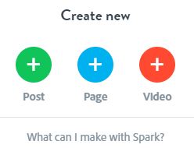
Create a Video
Title: Create a title for your video. You can skip this step and come back later.
Choose a Template: Or, you can “Start from Scratch”
Choose a Theme: Click through the themes to see what each will look like. Your choice will set up the font for the video.
Next, Add a Photo or Video: Choose a background picture or video for the title page. Click on the + button on the left side of the title page.
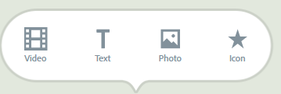 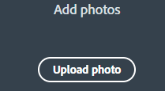 OR 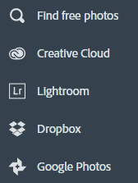
When you click “Photo”, a list of options is given to indicate where to get photos. Select “Find free photos.” Search will pull pictures from the Adobe Spark which are copyright free.
Add an Icon: When you click icon, you will find many different images that you can use to represent a character, scene, or something from the book that can be added to the book trailer.
Add a Video: When you click video, you will be able to choose a video from your computer (.mv4 or mp4 format). When the video opens, you can choose which section to use. You can only use 30 seconds for the video.

Add a Scene to Your Spark Video
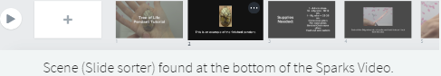
Click on the + to add a new scene to the sorter. You can drag the scenes to reorder them.
Choose a Layout for Your Scene (Slide): Click on “Layout” to choose from the 4 options.
To Delete a Slide: Right click on a slide and choose Delete.
Explore the Extras
Text: Choose the T and type. The more you type the smaller the letters get.
You can drag and drop your text anywhere on the slide.
Icons: Click on “Icon” and each palette appears.
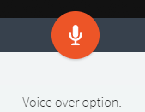
Finishing Touches
Voice Over: Click and hold down the microphone and speak in a normal conversational voice. Release the microphone icon when you are done. You can listen and re-record if needed.
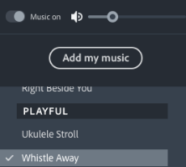
Music: In the upper right is the Music tab. It includes a list of music soundtracks to add to your video.

Preview: If there is not enough time for text to be read, change the length of how long the scene displays. In the bottom right corner of the tool bar, there is a grey circle with a number followed by the letter “s.“

Click the grey circle to display a slide bar to adjust the time to a maximum of 10 seconds. If it takes longer for the text, break it into 2 or more scenes.
Share: If you choose to share, fill in the required information.

