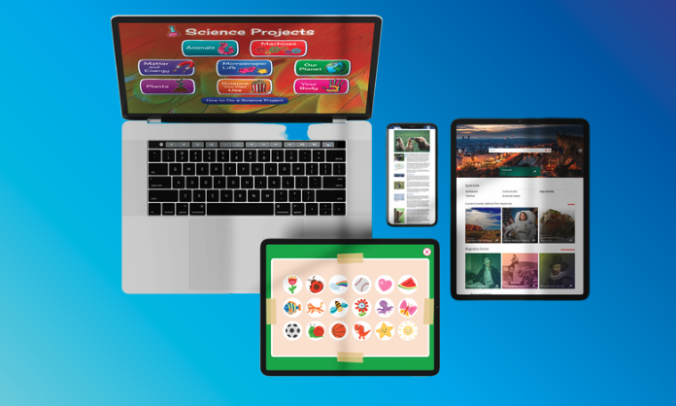

Dear parent or caregiver,

I’m so excited to introduce you to World Book ____________ . Through INFOhio, our school has access to the quality digital resources available from World Book.

World Book resources are filled with trusted, educational content that is fun and engaging for students, making it the perfect resource for school and at home! Use World Book for research, to look up cool facts together, or simply explore. Students love the digital activities, educational games, and real-life videos.

Access at home is free, and you can sign in on any device with an internet connection, including desktops, laptops, and tablets.

To help your child use the World Book resources, please go to the URL listed below and enter your school’s INFOhio username and password if needed.

If you need help, go to support.infohio.org.

Happy Learning!

To access World Book _________________
URL
School’s INFOhio Username
School’s INFOhio Password

